**Result report**

Non-ionic surfactants have been used as a rheology control additive in drilling fluids to prevent flocculation of solids, such as organoclays, and maintain mud dispersion.

In this study, computational molecular calculations and the Monte Carlo adsorption simulation were used to gain an understanding of the extent of the adsorption mechanism of non-ionic surfactants on hydrophobic surfaces such as organoclay. The Monte Carlo random walk simulations focused on the effects of non-ionic surfactant structure on the formation of adsorption layers on organoclay particles.

In other words, the fundamental phenomena involved in non-ionic surfactant adsorption on organoclays and how it affects the rheology of synthetic-based drilling fluids were elucidated by Monte Carlo simulations.

In this experiment, Monte Carlo random walk simulations used random number generation to move a molecule of on the lattice and to deposit it based on probability. This stage was aimed to investigate the deposition of molecules having different number of chains/branching and to correlate with the surface phenomena in drilling fluids.

Three types of non-ionic surfactants were used in the experiment, namely neopentyl glycol ester (NPGE; C41H76O4), trimethylolpropane ester (TMPE; C60H110O6), and pentaerythritol ester (PEE; C77H140O8). NPGE has two hydrophobic chains, TMPE has three hydrophobic chains, and PEE has four hydrophobic chains.

Then let’s see the experiment method.

The methodology flowchart for Monte Carlo simulations are presented in Fig.1. The simulation domain was a 100 × 100 square lattice used as a system boundary, as illustrated in Fig.2. The adsorption site boundary with the size of 60 × 60 square lattice was located in the middle of the domain. The system boundary was referred as the “boundary”, and the adsorption sites boundary as the “organoclay”.

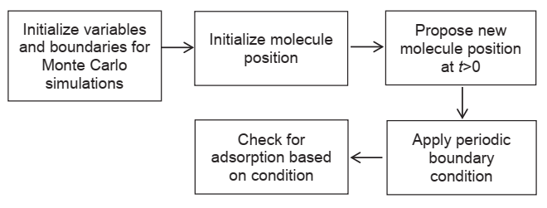

Fig. 1. Methodology flowchart for Monte Carlo random walk simulations.

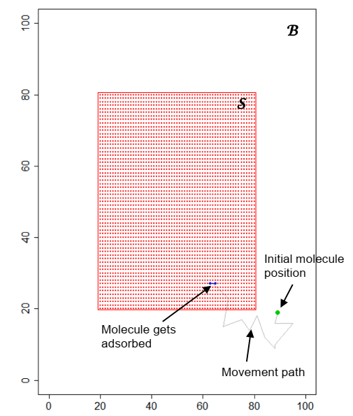

Fig.2. The simulation domain with the hypothetical of molecule movement path.

The initial molecule position is randomly placed outside of S (a green dot). The adsorption site (Sc) of the hydrophobic chain inside the S is shown as red dots. The study focused on the interaction of different structure of polyol esters on the surface.

Next, the step size, *ns*, was assigned. The total number of non-ionic surfactant molecules initially present in the system was defined as *nl*. Each of the lubricant molecules would travel through different routes due to Δ*P*(t). The number of simulation steps was defined as *nt*. The total amount of polyol ester that get adsorbed onto the organoclay sites can be different as *nt* was varied.

The adsorption probability was also set and defined as *np*.

Note that *np* is the same for all organoclay sites.

The polyol ester molecule moved in a periodic boundary condition. Hence, if *Pl*(t+Δt)B , then the molecule movement is described as,

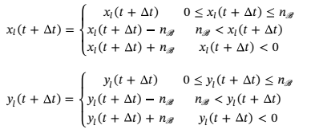

To determine whether a molecule had been adsorbed, the locations of the last vertex of each chain were observed.

The simulations were run to calculate the percentage of organoclay sites occupied by non-ionic surfactants and the percentage of non-ionic surfactant adsorbed on the organoclay, varying the input parameters such number of polyol ester molecule (*nl*), number of steps (*nt*), step size (*ns*), and the probability of non-ionic surfactant to be adsorbed (*np*). Finally, the simulation output, namely the percentage of organoclay sites occupied by non-ionic surfactants and the percentage of non-ionic surfactants adsorbed to the organoclay, were calculated using following Eqs.. The simulations were repeated five times and the mean value was reported.

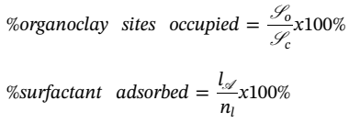

Next, there are results and analysis.

Fig. 3 shows the example of simulation output for different types of non-ionic surfactant molecules.

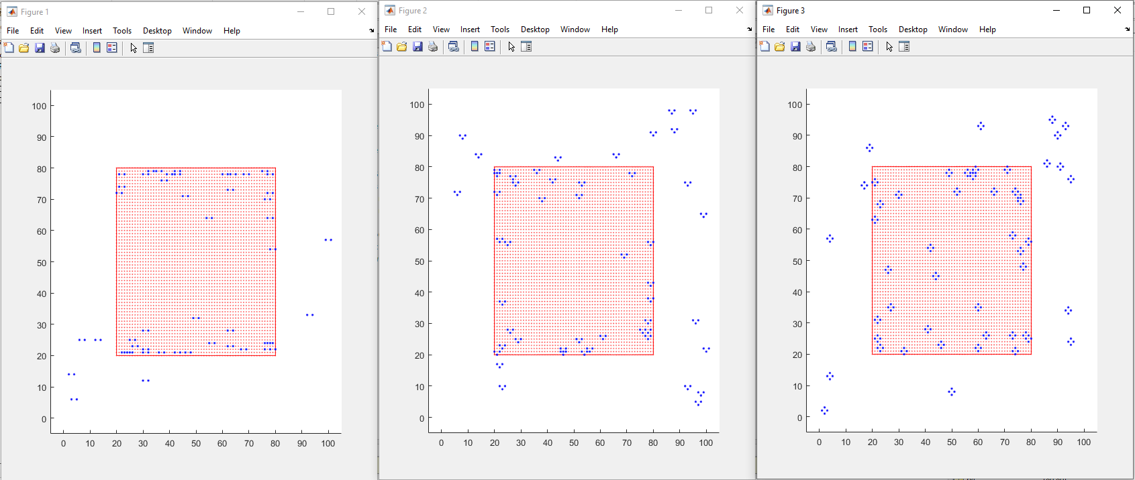

Fig.3. Predicted simulation output of different molecule chains.

First, a step size of ns = 5, adsorption probability np = 0.4, and nonionic surfactant molecule nl = 100 conditions were used to study the number of steps (nt) dependence. The simulations were run at nt between 25 and 200. The nt was counted by the number of steps for depositing the molecules and scaled by the total number of lattice sites.

Fig. 4 shows the mean values of non-ionic surfactant adsorbed (%) and organoclay site occupied by the non-ionic surfactant (%) at different number of steps (nt).

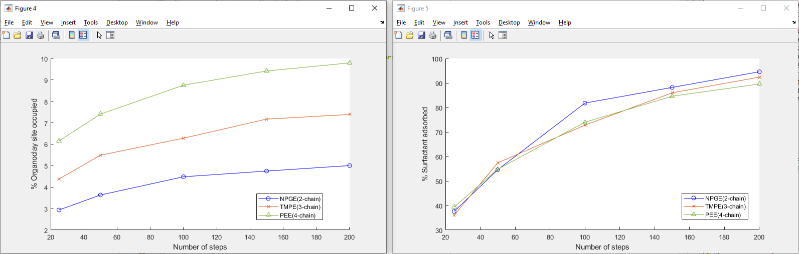

Fig.4. Percentage of molecule adsorbed and organoclay occupied at different number of steps.

It is shown that branching the molecules to 3- and 4-chain decreases the number of adsorbed molecules. And NPGE is shown to have more organoclay sites adsorbed compared to TMPE and PEE.This is because the smaller molecule finds it easier to fill the “gaps” at high loads within the adsorbate. However, since one molecule of PEE can occupy more sites due to a larger number of chains, the percentage of sites occupied is higher than NPGE.

Next, the effect of the number of non-ionic surfactant molecules was simulated by varying the nl, as shown in Fig. 5.

Fixed values of number of steps nt = 100, step size ns = 5, and adsorption probability np = 0.4 were used. As nl increased, the relationship between nl and the percentage of non-ionic surfactant adsorbed on the clay shows no clear trend.

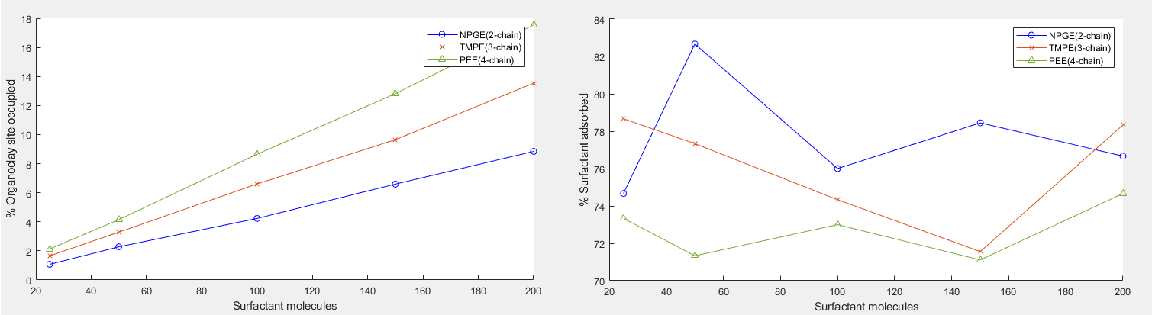

Fig. 5. Percentage of molecule adsorbed and organoclay occupied at different molecule concentration.

Simulations were also performed for various length of random walks (step size) defined as ns, and the results are shown in Fig. 6. Fixed values of number of steps nt = 100, non-ionic surfactant molecule nl = 100, and adsorption probability np = 0.4 were used. The plot of ns vs non-ionic surfactant adsorbed indicates that it is still in line with the previous results.

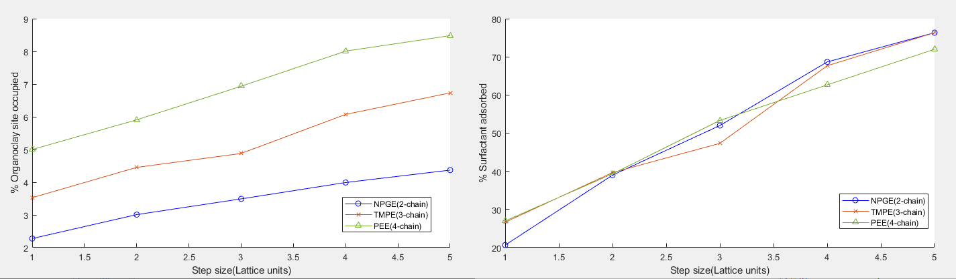

Fig. 6. Percentage of molecule adsorbed and organoclay occupied at different step size.

Lastly, the adsorption probability (np) would affect the number of molecules adsorbed, for example that the walk may pass through any lattice site multiple times before it gets adsorbed.

Fixed values of number of steps nt = 100, non-ionic surfactant molecule nl = 100, and step size of ns = 5, were applied.

The results in Fig. 7(a) indicate that the percentage of molecule adsorbed increases with the adsorption probability.

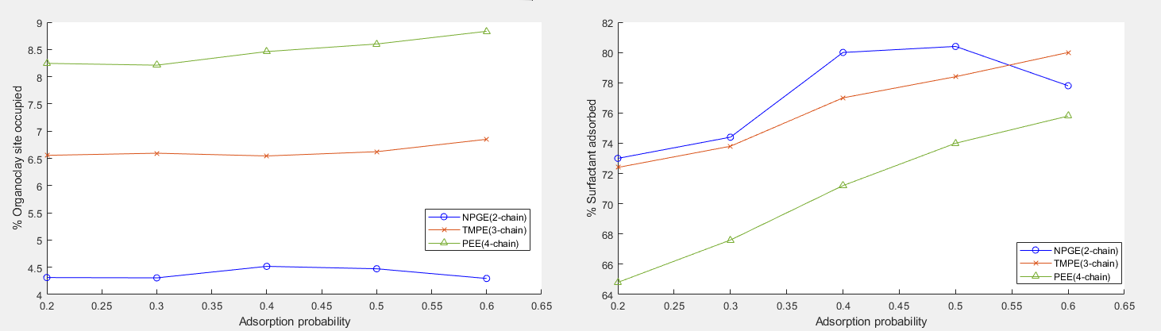

Fig.7. Percentage of molecule adsorbed and organocay occupied at different adsorption probability.